ARZU ÖZPOLAT
English Language Instructor

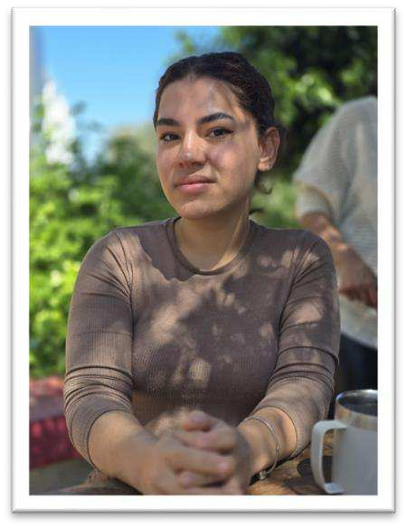
PROFILE
English language teacher having teaching experience with a practical “get the things done” approach, who always perseveres to active the best results. Enthusiastic in language teaching and maintain very good teacher student relationship.

CONTACT
+90 533 856 5468
arzuzplt@gmail.com

SKILLS
- Knowledgeable in special education.
- Has very good time management skills.
- Good at classroom management.
- Has very good communication skills.
- Test design skills.
- Familiar with CEFR.
- Loves to work with children

LANGUAGES
Russian – Native Turkish – Native English – Fluent

EDUCATION
Final International University (2018-2022)

WORK EXPERIENCE
Final International University - English language instructor
2022- Present
Key responsibilities:
- Taught to every students of every CEFR level
- Member of the testing team
- Testing team A1 – A2 level organizer

23 Nisan Pre-School - teacher trainee
2021-2022

CERTIFICATES
- Honor certificate / 2020- 2021 fall semester
- Honor certificate / 2021- 2022 fall semester

- High honor certificate / 2021-2022 spring semester

- GIKAD II Entepreneurship Camp - Participation certificate

PUBLICATIONS
Kole, A., Tokgöz, E. D. & Özpolat, A (2022). Rising trend: Adults' views and preferences on mobile assisted language learning apps in the TRNC. Kosovo Educational Research Journal, 3(1), 63-85.

REFERENCES
Nazife Aydınoğlu – Dean of The Faculty of Education / Coordinator of ELT department in Final International University
Çiğdem Cantaş – Director of the SFL department in Final international University
Assoc. Prof. Dr. Mete Girgen – Kyrenia City Councilor

